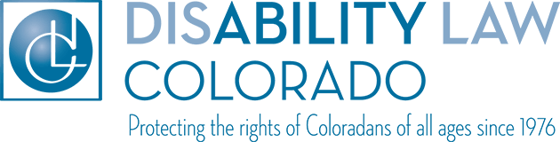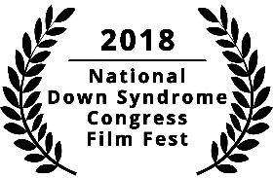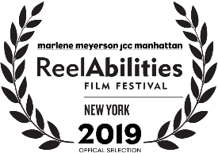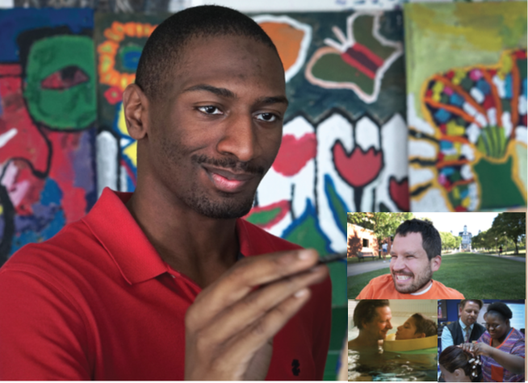

SAVE THE DATE

Friday, March 6, 2020

An award winning documentary from filmmaker Dan Habib.

INTELLIGENT LIVES stars three pioneering young American adults with intellectual disabilities – Micah, Naieer, and Naomie – who challenge perceptions of intelligence as they navigate high school, college, and the workforce. Academy Award-winning actor and narrator Chris Cooper contextualizes the lives of these central characters through the emotional personal story of his son Jesse. INTELLIGENT LIVES challenges what it means to be intelligent, and points to a future in which people of all abilities can fully participate in higher education, meaningful employment, and intimate relationships. Film length: 70 minutes

Save the date- Registration information will be sent out soon

Friday, March 6, 2020

5:15-6:15 Light Refreshments

6:15-7:45 Movie Showing

7:45-8:30 Panel Discussion

University of Colorado Anschutz Medical Campus

13121 E. 17th Ave.

ED2 South, Room 1104

Hosted by Community of Practice (CoP) on Cultural and Linguistic Competence in Developmental Disabilities

Join us for a free screening of